Candace Gay Memorial Scholarship Application
Norton Community High School Graduating Senior, Class of 2020

Eligibility: This scholarship is open to any graduating senior in good standing from Norton Community High School who has participated in one or more of the following activities during their time at NCHS: Drama, Forensics, Art, Music, or Scholars Bowl. There is no minimum GPA or ACT requirement.

Name: _____________________________________________________________________________

Mailing Address: __________________________________________________________________

__________________________________________________________________

Phone Number: __________________________________________________________________

I was involved in the following activities (please list year involved in numerical format, ie: 9, 10, 11, 12)

Art: __________________________________________________________________________________

Drama: _______________________________________________________________________________

Forensics: ___________________________________________________________________________

Music (Band or Vocal): ______________________________________________________________

Scholars Bowl: ______________________________________________________________________

Essay Question (please attach a separate piece of paper)

The creative process drives some people more than others, and it can be developed and evolved through involved with the arts programs listed above. How has your educational experience changed because of your involvement with the academic arts?

Applicant’s Signature: _______________________________________________________________________
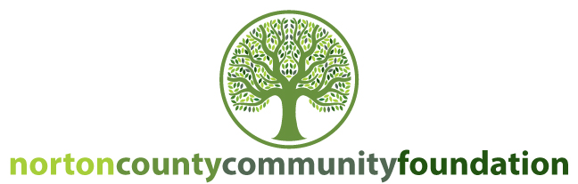
Scholarship available through the Candace Gay Memorial Fund held
at the Norton County Community Foundation.

